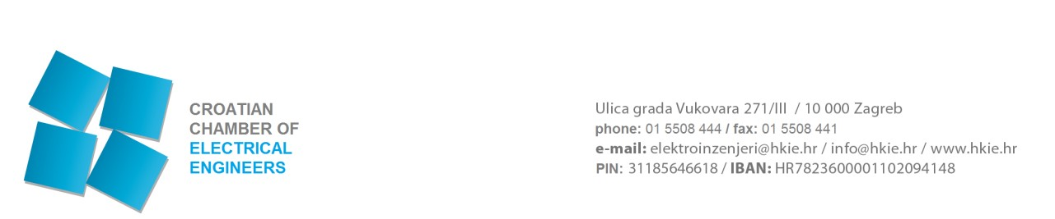ZAHTJEV ZA UPIS U IMENIK STRANIH OVLAŠTENIH OSOBA

REQUEST FOR ENTRY INTO THE DIRECTORY OF FOREIGN CHARTERED PROFESSIONALS OF ELECTRICAL ENGINEERING PROFESSIONS

Date of receipt: |  | Number and date of entry:
CLASS:
REG.NO.: |  | CLASS:
 |  | REG.NO.:
Administrative fee: |  | Date of decision:

1. PERSONAL DATA
NAME: SURNAME:
Gender: Passport or personal ID card number:
Date of birth: Place of birth:
Country of birth: CITIZENSHIP:
PERMANENT RESIDENCE (required) Street and house number:
Postal code: City: Country:
PERSONAL CONTACT DETAILS (required)
Phone: Mobile phone:
E-mail:
CONTACT DETAILS IN THE REPUBLIC OF CROATIA (required) Street and house number:
Postal code: City: Country:
Phone: Mobile phone:
E-mail:

2. REGULATED PROFESSION
Name of the regulated profession, which you will perform in the Republic of Croatia

chartered electrical engineer,

chartered construction manager of the electrical engineering profession

chartered performance manager of the electrical engineering profession
Are you qualified to perform the abovementioned regulated profession, that is, activity in the EU Member State in which you are domiciled (circle)? YES / NO
Is formal education enabling you to perform the subject profession organized in the EU Member State in which you are domiciled (circle)? YES / NO

3. EDUCATION AND TRAINING
Name of the educational institution (in native language):
Address of the educational institution:
Name of the completed study:
Acquired title:
Date of graduation: University degree number:
Place of graduation: Country of graduation:
POSTGRADUATE DEGREE:
Master’s degree-field: Year of acquisition:

Doctoral degree-field: Year of acquisition:
OTHER PROFESSIONAL QUALIFICATIONS (PROFESSIONAL EXAM):
Indicate additional qualifications and the field in which you are further qualified:

4. PROFESSIONAL EXPERIENCE
Professional experience in performing the respective regulated profession, that is, regulated professional activity (provide dates, work organisations, job title and attach relevant certificates) - certified translation:

5. CONTACT DETAILS IN THE COMPANY OF EMPLOYMENT (required)
Company name and form of organisation:
Address:
Postal code and city:
Company registration number:
Phone: Fax: Mobile phone:
E-mail:
Job title:
Date of commencement of employment:
Responsible person of the company:
6. KNOWLEDGE OF CROATIAN LANGUAGE
I know Croatian language (please indicate the degree of knowledge of the language):
- - beginner/minimum knowledge
- – independent knowledge of the language
C - experienced knowledge

7. POWER OF ATTORNEY:
By signing the request, I hereby authorise the person stated below to take over on my behalf the complete documentation issued by the Chamber on the basis of my request
Name and surname of the authorised person:
Telephone/GSM (with the area code):
E-mail:

PLEASE INFORM ME OF THE COURSE OF THE PROCEDURE BY:

Mail: ___________________________
Fax: ___________________________
E-mail: _________________________
Via the authorised person: ____________

I WILL TAKE OVER THE DECISION ON THE RECOGNITION OF FOREIGN QUALIFICATIONS
(please circle):

- At the Chamber
- By mail (please enter the correct address): _________________________________

BY DULY SIGNING THE SUBJECT REQUEST, I HEREBY DECLARE:

  - UNDER PENALTY OF PERJURY THAT THE ABOVE INFORMATION IS TRUE, AS WELL AS THE SUBMITTED DOCUMENTATION AND APPENDICES TO THIS REQUEST;
  - THAT I AM WORTHY OF PERFORMING ENGINEERING TASKS, THAT I AM MEDICALLY FIT AND LEGALLY CAPABLE, THAT I HAVE NOT BEEN CONVICTED OF A CRIME AGAINST THE REPUBLIC CROATIA, FOR A CRIME AGAINST OFFICIAL DUTY OR FOR A CRIME COMMITTED OUT OF GREED THAT WOULD RENDER ME MORALLY UNWORTHY OF PRACTICING ENGINEERING TASKS ACCORDING TO THE CODE OF PROFESSIONAL ETHICS;
  - THAT I AGREE THAT MY PERSONAL DATA, PURSUANT TO THE PROVISIONS OF THE PERSONAL DATA PROTECTION ACT, MAY BE COLLECTED, PROCESSED AND STORED BY THE CROATIAN CHAMBER OF ELECTRICAL ENGINEERS;
  - THAT I SHALL APPLY THE REGULATIONS OF THE REPUBLIC OF CROATIA AND ACTS OF THE CHAMBER ADOPTED THEREUNDER DURING THE PERFORMANCE OF WORK IN THE REPUBLIC OF CROATIA;
  - THAT I AGREE THAT MY PERSONAL DATA FROM THE RECORDS OF THE CROATIAN CHAMBER OF ELECTRICAL ENGINEERS BE PUBLISHED;
  - THAT I USE CROATIAN LANGUAGE AND LATIN SCRIPT FOR THE PURPOSES OF THE PROFESSION IN THE REPUBLIC OF CROATIA, THAT IS, THAT I SHALL USE TRANSLATION SERVICES AT MY OWN RISK AND COST.

Place and date: ______________________ Signature:________________________

Terms used in this Request in masculine gender are neutral and refer to both male and female persons.
APPENDICES (required)

- Certificate of citizenship (copies)
- Evidence of registered residence or establishment in the Republic of Croatia (copy)
- Employer's confirmation of employment in the company of employment (date of employment, job title, type of work you perform, etc.)
- Decision of the Chamber on the recognition of foreign qualifications
- Certificate/Declaration of no criminal record (copies - translation) -not older than 6 months
- Confirmation of the passed professional examination in the Republic of Croatia
- Photo (the size of an ID card photo 35x45 mm).
- Confirmation of payment of the registration fee:

amount: 265,00 EUR
recipient: CROATIAN CHAMBER OF ELECTRICAL ENGINEERS, Zagreb, Ulica grada Vukovara 271
account number of the recipient: HR7823600001102094148
description of payment: name and surname (of the applicant) - Registration fee for entry into the Directory of foreign chartered professionals

.

